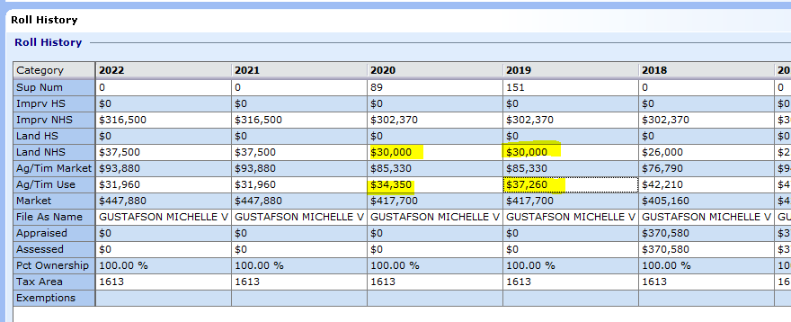

ADD THESE TWO 30,000 + 37,260 = 67,260 (UNDER **CUR USE LAND**) EXAMPLE FROM PID 287679

